

TEMENOS T24

Stream

User Guide

Table of Contents

Device Storage Widget <Code>

Introduction 3

Preface 3

Overview of Device Storage Widget - Input Type 3

Overview of Device Storage Widget - Button Type 3

Assumptions 3

Getting Started 3

Installation 3

Device Storage Input Type 4

Device Storage Button Type 4

# 

# Introduction

## Preface

This User Guide is intended for Developers and provides the step by step instructions for adding a new custom button widget called Device Storage and a Device Storage input type widget, in your presentation.

## Overview of Device Storage Widget - Input Type

This has the same behavior as a normal question input, except that the input value is taken from the Device Storage by a specific key, in case it is not set within the Edge data store. If the input value is set within Edge data store and if it is different from the Device Storage correspondent, then when the page is loaded (on DeviceReady event), the Device Storage is updated automatically.

## Overview of Device Storage Widget - Button Type

Here, the Device Storage is a button widget instead of being an input type widget, in your presentation.

## Assumptions

It is assumed that you are familiar with the edgeConnect Editors and have working knowledge on edgeConnect.

# Getting Started

## Installation

For installation of both input type and button type widget:

1. Copy **com.temenos.widgets.hybrid.deviceStorage** folder in your widgets folder (Ex: /{your project/templates })
2. Copy the content of **Insert in widget.xml** in your widget.xml file within your project.
3. Make sure the **cordova_loader.js** file is inserted in your template header for the phase where you want to use the **Device Storage** widget.
4. Insert ***<script src="$$HTML_LOCATION$/js/cordova/cordova_loader.js"></script>*** in your header TPL.

## Device Storage Input Type

To create a device storage input type widget:

1. You will have to insert a new question in the **Process Editor**.
2. In the **Presentation Editor** double-click on the proper input and navigate to **Answer** -> **Control tab** -> **Display Type**.
3. Select the **Device Storage** type.
4. Within **Widget Details** tab you have to set up the widget settings.

* **Item Key field** - item's key within the storage device associated with this question (The key with which, data are saved (Question's answers) within Device Storage )
* **Storage Type** - There are two kinds of storage:
* PERMANENT - the data are saved persistent in device memory.
* TEMPORARY - works the same way in every respect, except that all data is cleared each time the application closes.

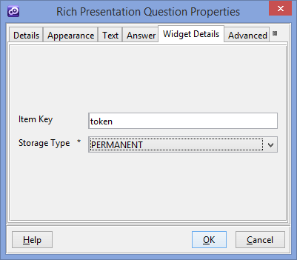

## Device Storage Button Type

To create a device storage button type widget:

1. Add a new custom button in your presentation.
2. In **Appearance** -> **Button tab** for **Display Type** field, you have to select **Device Storage Button**.
3. Within **Widget Details** tab, you have to set up the widget settings.

* Storage Type - There are two kinds of storage namely :
* PERMANENT - the data are saved persistent in device memory.
* TEMPORARY - works the same way in every respect, except that all data is cleared each time the application closes.
* Button Action - the storage function that is called when the button is clicked.
* SET ITEM - assigns a keyed item's value.
* GET ITEM - returns the item identified by the specified key.
* REMOVE ITEM - removes the item identified by the specified key.
* CLEAR - removes all of the key/value pairs.
* Item Key field - item's key within the storage device associated with this button
* Item Value field - this is applicable only for SET ITEM action.
* InputID field - ID of Input where storage value is saved. This is applicable only for GET ITEM Action.
* Auto click check box – enables or disables auto click button, when the page is loaded.

